Washington State PTA Region 6, Northshore, Shoreline and Seattle PTSA Councils
invite you to
EVERY STUDENT SUCCEEDS ACT (ESSA) CONSOLIDATED PLAN Q&A
WITH WASHINGTON STATE DEPUTY SUPERINTENDENT
DR. GIL MENDOZA
The ESSA changes the face of education across the nation. It is more flexible and permissive, allowing local school districts to better meet the needs of their students. WSPTA Region 6 and its PTSA Councils are pleased to provide the opportunity for you to ask questions about Washington State's ESSA Consolidated Plan Draft. Your voice on behalf of the students in Washington is important.
Washington State Deputy Superintendent Dr. Gil Mendoza will be present to discuss the Consolidated Plan. Come learn about how to provide input on this living document. The ESSA plan summary, the review tour PowerPoint presentation and the webinar are available for review at the OSPI website at http://www.k12.wa.us/esea/essa/default.aspx. Bring your questions!
Date: Saturday, December 10, 2016
Time: 9:00 a.m. to 10:30 a.m.
Location: Shoreline Conference Center
18560 1st Ave NE, Shoreline, WA 98155
RSVP at https://www.eventbrite.com/e/essa-consolidated-plan-qa-with-ospis-dr-gil-mendoza-tickets-29864505540
Sample questions:
How will ESSA effect my child?
How will ESSA be implemented at the local district? Local school?
What is a School Improvement Plan (SIP)?
What are alternative assessments and which students are eligible?
Will assessments be available in multiple languages?
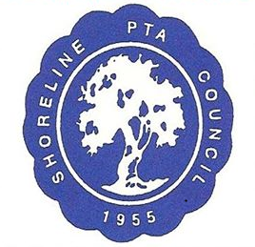
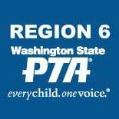
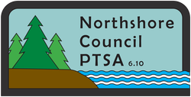
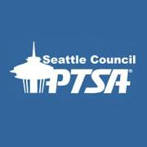
PROUDLY SPONSORED BY:
In Partnership with
Shoreline Public Schools

Absentee questions, translation services and childcare will be provided with prior request (by 8 a.m. 12/8). Please contact WSPTA Region 6 Director Sherry Rudolph ptareg6@wastatepta.org or Personal Message at https://www.facebook.com/wsptareg6/
with any requests.

