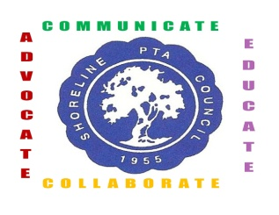
Shoreline PTA Council #6.12
Senior Scholarship Application
2016-17

Requirements:

2017 Graduate of Shorecrest or Shorewood High School
Cumulative GPA of 2.5 or above – verified by school counselor
Post-high school study emphasis at college, university, or vocational/technical school

This complete application must be received by June 1st 2017. Mail to: Shoreline PTA Council, PO Box 55832, Shoreline, WA 98155

Name _________________________________________ Phone ________________

Address _______________________________________ Email ________________

High School Graduation from ____________________________________________

Cumulative Grade Point Average _________________________________________

Counselor’s Verification (signature) _______________________________________

Counselor’s Name ____________________________________________________

Post High School Study Emphasis ________________________________________

School expecting to attend ______________________________________________

Address ______________________________________________

City _____________________ State ____________ Zip _______

Scholarship amount is up to $500
If you have any questions, please contact your school counselor or the Shoreline PTA Council Scholarship Committee. email: shorelineptacouncil@gmail.com.

everychild.onevoice

