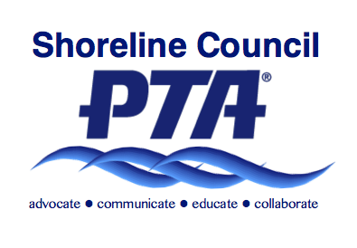
Shoreline PTA Council 6.12
Reimbursement Check Request Form
Reimbursement Procedure

Fill out this voucher, attach receipts and have the Committee Chair authorize. A Committee Action Plan must be submitted to the board of directors for approval at the beginning of the PTA year. The expenses must not exceed the approved budget, prior approval of the board of directors is also required before spending any amount over the approved budget. Mail or Email completed form to council treasurer.

Return the completed form by mail to:  Shoreline PTA Council 6.12  PTA Council Treasurer  P.O. Box 55832  Shoreline, WA 98155-5784 | Return the completed form by e-mail to:  shorelineptatres@gmail.com
Date: | Amount:
Check requested by:
Check payable to:
Committee: Total:
Committee chair signature: _________________________________
Check authorized by*: _____________________________________
Reimbursement for:
Check Delivery Options
Mail to:
Leave in Shoreline PTA Council office
Deliver in person
X
Email and I will pick up

*Authorization must be made by current board member preferably over said committee.

Treasurer use only

Date Paid: ___________
Amount Paid: ________
Check Number _______

Notes:

