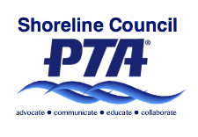
Shoreline PTA Council 6.12
Senior Scholarship Application
2017-18

Requirements:

2018 Graduate of Shorecrest or Shorewood High School
Cumulative GPA of 2.5 or above – verified by school counselor
Post-high school study emphasis at college, university, or vocational/technical school

This complete application must be received by your school counselor by the end of school on Friday, June 1st, 2018. Please submit your application directly to the counselor at Shorecrest or Shorewood. DO NOT MAIL OR EMAIL THE APPLICATION.

Name _________________________________________ Phone ________________

Address _______________________________________ Email ________________

High School Graduation from ____________________________________________

Cumulative Grade Point Average _________________________________________

Counselor’s Verification (signature) _______________________________________

Counselor’s Name ____________________________________________________

Post High School Study Emphasis ________________________________________

School expecting to attend ______________________________________________

Address ______________________________________________

City _____________________ State ____________ Zip _______

Scholarship amount is up to $500
If you have any questions, please contact your school counselor or the Shoreline PTA Council Scholarship Committee. email: shorelineptacouncil@gmail.com.

everychild.onevoice

